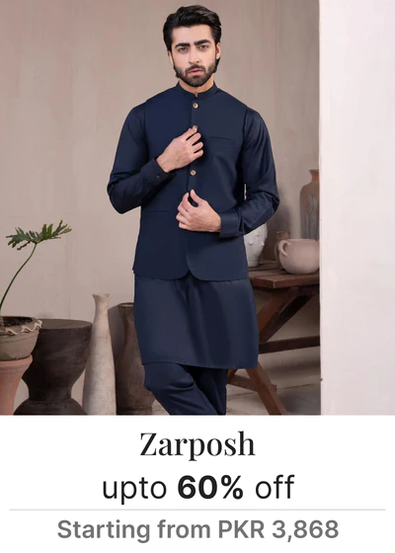

**Description of the outfit:**

* Type: Suit
* Color: Dark blue
* Material: Light weight
* Size options: XS, S, M, L, XL
* Style: Classic and timeless
* Care instructions: Dry clean only
* Availability: Limited stock